ABSTRACT

According to popular scientific theories, the universe is said to consist of 4-dimensions ( 3 space co-ordinates and a time co-ordinate). It states that space and time are interlinked together to form a space-time continuum. Here the universe is said to be a fabric of space-time and that mass bends this fabric and any object accelerating through it produces ripples in space-time. These are gravitational waves. LIGO observatories are constructed for the sole purpose of detecting these waves. LIGO's two four-kilometer-long arms are placed in an L-shape, allowing one arm to stretch while the other shortens as a wave passes through. Although the forecast for this prediction was made over 100 years ago, equipment sensitive enough to detect them has only recently become available. Not only is the effect insignificant, but the signal is so weak that it might be overpowered by something as insignificant as a cricket ball being dropped near LIGO's mirrors. There are numerous factors that can obstruct detection or cause a misleading signal. Detection of these waves is a complex process that requires highly sensitive massive equipment. The computational complexity of typical approaches like matched-filtering and Bayesian inference is a major barrier to real-time detection and parameter estimation of gravitational waves from compact binary mergers. Time-series data from three LIGO Observatories are collected and preprocessed by taking the time difference and alignment into consideration. These signals are then whitened by removing Gaussian and white noise from the signals by applying signal processing filters like Constant-Q transform, Wiener filter, and bandpass filtering. The SNR of these signals is increased. Fourier transform is applied to the time-series data to convert it into the Frequency domain to efficiently figure out the essential frequencies. The waves are then used as training data for Deep Learning models like 1-D CNN, and regression CNN for detection and parameter estimation of the gravitational waves signal in the data. These findings highlight the importance of using realistic gravitational-wave detector data in machine learning approaches and represent an important step toward real-time detection and inference of gravitational waves.

LIST OF FIGURES

It depicts the curvature caused in the fabric of space-time by the accelerated-motion of the Earth 1
  - First image of a black hole captured in 2018 . . . . . . . . . . . . . . . . . . . .2
  - Simulation of gravitational waves being emitted from compact binary mergers Functioning of LIGO equipment in detecting GW . . . . . . . . . . . . . . . . . 3
  - System Architecture Diagram . . . . . . . . . . . . . . . . . . . . . . . . . . . . 7

  - CNN architecture diagram used for this project . . . . . . . . . . . . . . . . . 8
  - Basic Architecture of a CNN . . . . . . . . . . . . . . . . . . . . . . . . . . . . . 9
  - Data strains for normal vs normalized plotted for three observatories in time domain . . . . . . . . . . . . . . . . . . . . . . . . . . . . . . . . . . . . . . . . . . . . . . . . . . . . . . . 13 LIGO strain transformed to frequency domain . . . . . . . . . . . . . . . . . . .13

PSD for a sample signal 14
  - ASD for a sample signal . . . . . . . . . . . . . . . . . . . . . . . . . . . . . 14
  - Lowpass filtered vs unfiltered plotted parallelly . . . . . . . . . . . . . . . . . . . . . . . . . . 15
  - CQT Filtered Signal . . . . . . . . . . . . . . . . . . . . . . . 15
  - Data Preprocessing module . . . . . . . . . . . . . . . . . . . . . . . . . . . 11
  - Data Visualization Module . . . . . . . . . . . . . . . . . . . . . . . . . . . . . . . . . . . . . . . . . . 11
  - Accuracy of the model . . . . . . . . . . . . . . . . . . . . . . . . . . . . . . . . . . . . . . .29
  - Score of the model determined from mean error of the predicted value . . . . . . . 29

v

ABBREVIATIONS

DL Deep Learning
CNN Convoluted Neural Network
ML Machine Learning
GW Gravitational Waves
LIGO Laser Interferometer Gravitational-wave Observatory
BH Black Hole
BBH Binary Black Hole
BNS Binary Neutron Star
NN Neural Network
ASD Amplitude Spectral Density
PSD Power Spectral Density
FT Fourier Transform
FFT Fast-Fourier-Transform
DFFT Discrete-Fast-Fourier-Transform
CQT Constant Q-Transform
ReLU Rectified Linear Unit
FC Fully Connected Layer
RMS Root Mean Square
DF Data Frame
UI User Interface
FS Frequency Sample
Hz Hertz
s Seconds

INTRODUCTION

  - Background
- Einstein’s General Theory of Relativity
Einstein's General Theory of Relativity was his attempt to redefine gravity. He established that the laws of physics apply to all non-accelerating observers, and he demonstrated that the speed of light in a vacuum remains constant regardless of the speed at which an observer travels.
As a result, he came to the conclusion that space-time could be intertwined into a single-continuum known as space-time. Events that happen at the same time for one observer may occur at alternative timelines for others.
According to this theory, the universe has four dimensions (3 space co-ordinates and a time co-ordinate). It asserts that space and time are inextricably linked to form a space-time continuum. The universe is described as a fabric in this context.
- Space-Time continuum
The space-time continuum has four dimensions: three of space (length, width, and height...or, depending on how you want to think of them, up/down, left/right, and forward/backward) and one of time.
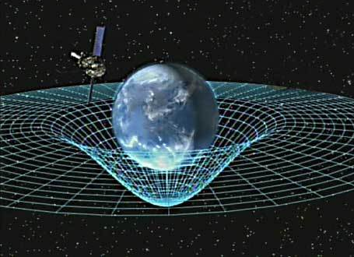

Fig 1.1: Curvature caused in the fabric of space-time by accelerated motion of Earth

- Black Holes
Nothing, not even light, can escape from this cosmic body of extreme gravity. Black holes are formed from the death of massive stars. When internal-thermonuclear-fuels run out in its core the stars walls start collapses in. After the fuels are depleted at the end of its life, the core becomes unstable and gravitationally collapses inward upon itself, thus causing the star's outer layers to be blown away. Matter starts compressing in from all directions and what’s left of all of this a singularity that is so potent not even light can escape its gravitational pull.

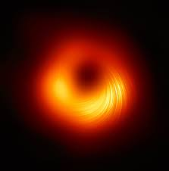

Fig 1.2: First image of a black hole captured in 2018

  - Gravitational Waves
Gravitational waves are 'ripples' in space-time caused by some of the Universe's most violent and energetic processes. In his general theory of relativity, Albert Einstein predicted the existence of gravitational waves in 1916. Einstein's mathematics demonstrated that massively accelerating objects (such as neutron stars or black holes orbiting each other) disrupted space-time in such a way that 'waves' of undulating space-time propagated in all directions away from the source. These cosmic ripples would travel at light speed, carrying information about their origins as well as hints about the nature of gravity itself.
Despite Einstein's prediction of gravitational waves in 1916, the first proof of their existence did not arrive until 1974, 20 years after his death. In that same year, two astronomers working at Puerto Rico's Arecibo Radio Observatory discovered a binary pulsar, which is exactly the type of system predicted by general relativity to emit gravitational waves. Knowing that this discovery could be used to put Einstein's audacious prediction to the test, astronomers began measuring how the orbits of the stars changed over time. After eight years of observations, they discovered that the stars were approaching each other at the rate predicted by general relativity if they were emitting gravitational waves.
On September 14, 2015, LIGO detected undulations in spacetime caused by gravitational waves generated by two colliding black holes 1.3 billion light-years away.

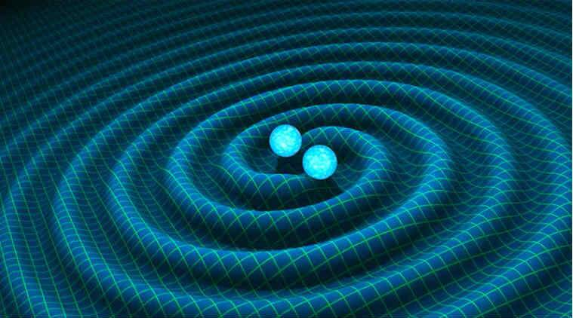

Fig 1.3: Simulation of gravitational waves being emitted from compact binary mergers
  - Laser Interferometer Gravitational-Wave Observatory
LIGO is an acronym that stands for "Laser Interferometer Gravitational-wave Observatory." It is a large observatory built for the sole purpose of detecting GW signals. It could be considered to be a marvelous piece of engineering. LIGO, which is made up of multiple massive laser interferometers spaced 3000 kilometers apart, uses the physical-aspects of light/space itself to make a detection. It in-turn helps physicists understand the origins of GW and the universe itself.

Fig 1.4: Functioning of LIGO equipment in detecting GW
The LIGO experiment looks for distortions in space-time that indicate the passage of gravitational wave signals through the Earth. A laser beam is split into two 4 km long arms that contain mirrors. The laser beams reflect off of mirrors and converge at the crux of the arms, causing them to travel different distances. A light detector can detect this mismatch. This time series data from these observatories is used to build a model capable of predicting whether or not a LIGO detector signal contains a gravitational wave.
  - Problem Statement
Gravitational waves, despite having been theoretically predicted around 100 years ago, were discovered very recently. The reason for it being the effects experienced by us on Earth is miniscule. Even current technology is barely sensitive enough to detect them. There is a necessity for highly efficient models that are capable of analyzing large amounts of data and effectively predict the existence of such a wave in a specific data sample.

CHAPTER 2

Literature Survey

Ref.no | Title | Overview | Published in | Year of publication
[1] | Observation of Gravitational Waves from a Binary Black Hole Merger | The first observation of gravitational waves at LIGO observatories is explained | APS Physics | 2016
[2] | Matching Matched Filtering with Deep Networks for Gravitational-Wave | Use of matched filtering for detection of gravitational wave is explained | APS Physics | 2018
[3] | Enhancing gravitational-wave science with machine learning | Different signal processing techniques an waveform modeling is explained | IOP Science | 2021
[4] | Detection and parameter estimation of Gravitational waves using DL | A regression CNN for detection and 1-D CNN for parameter estimation is explained | ScienceDirect | 2021
[5] | Deep Learning for real-time gravitational wave detection and parameter estimation: Results with Advanced LIGO data | Deep Filtering method for noise reduction is provided. | ScienceDirect | 2018

Ref.no | Title | Overview | Published in | Year of publication
[6] | Barlow Twins: Self-Supervised Learning via Redundancy Reduction | Barlow Twins Self-Supervised Learning Neural network is defined | ARXIV | 2018
[7] | nnAudio: An on-the-Fly GPU Audio to Spectrogram Conversion Toolbox Using 1D Convolutional Neural Networks | nnAudio Python module for signal processing is explained | IEEE | 2019
[8] | Fourier transform of the continuous gravitational wave signal | Fourier transform for analyzing the wave in frequency domain so as to get relevant frequency range in which the wave could be present. | APS | 2021
[9] | Insight into the noise reduction Wiener filter | Wiener filter a signal processing technique for noise reduction is explained. | IEEE | 2020
[10] | Deep learning searches for gravitational wave stochastic backgrounds | 1D and a 2D convolutional neural network (CNN) and a Long Short Term Memory (LSTM) networkfor gravitational wave analysis | IEEE | 2021

Ref.no | Title | Overview | Published in | Year of publication
[11] | From One to Many: A Deep Learning Coincident Gravitational-Wave Search | In this section the model uses a complex neural-network(NN) trained on the data from a single detector like a single LIGo Observatory and this is used to make a prediction for a GW in a signal | ARXIV | 2021
[12] | PyDub: An on-the-Fly GPU Audio to Spectrogram Conversion Toolbox Using 1D Convolutional Neural Networks | PyDub Python module for signal processing is explained | IEEE | 2019
[13] | Fourier transform of the continuous gravitational wave signal | Fourier transform for analyzing the wave in frequency domain to get relevant frequency | APS | 2021
[14] | Insight into the noise reduction Wiener filter | Wiener filter for noise reduction is explained | IEEE | 2020
[15] | Deep learning searches for gravitational wave stochastic backgrounds | 1D and a 2D convolutional neural network (CNN) and a Long Short Term Memory (LSTM) network  for gravitational wave analysis | IEEE | 2021

CHAPTER 3

3 SYSTEM ARCHITECTURE AND DESIGN

The main objective of the project is to develop a ML/DL model that is capable of predicting if a LIGO detector signal contains a gravitational wave or not.
The system architecture and modules description is as follows

3.1 System Architecture

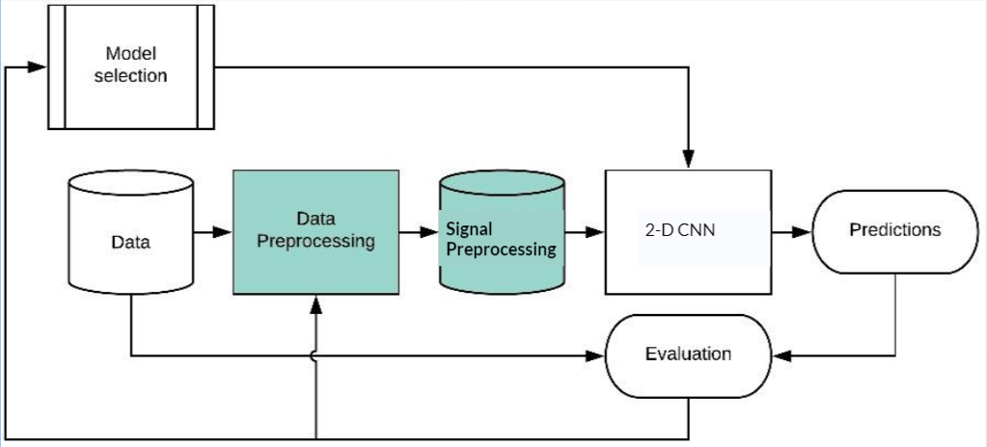

Fig 3.1: Architecture Diagram of the system employed

The system architecture is as follows.

3.1.1 Data:
The dataset used was time-series data gathered from LIGO observatories that contain either detector noise or signal along with detector noise. The signals are extremely weak having a very less signal to noise ratio. Most of the data is from simulated gravitational waves rather than actual waves. These waves are derived from relativistic equations and use real parameters.
The dataset consists of more than 20000 data samples divided into train and test sample sets that are later used as such.
3.1.2 Data Preprocessing:
The data gathered as mentioned as above are preprocessed to convert it into the format that we could later use. These preprocessing methods involve converting the data

into the required format, converting it into frequency domain to analyze the relevant frequencies, etc.

3.1.3 Signal Preprocessing:
As mentioned above the preprocessed data have a very low SNR. Thus poses a great obstacle in detecting these underlying signals. To increase the SNR the data is applied upon by a few signal processing techniques. These methods include Wiener filter, whitening the signal, smoothening the signal using methods like centered moving avg, low-pass filter to filter out unnecessary high frequency signals, etc.

To explain the architecture as a whole, the data is first preprocessed and later signal processing techniques are applied to increase SNR. This data is later passed as input to the suitable ML/DL model. The models validation metrics like accuracy, precision, etc. are evaluated and compared with other similar models. The model that works the best is chosen as the prediction model.

3.2 2-D CNN Architecture

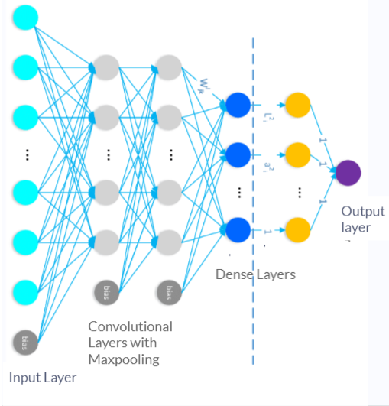

Fig 3.2: CNN architecture diagram used for this project

3.2.1 Basic Architecture

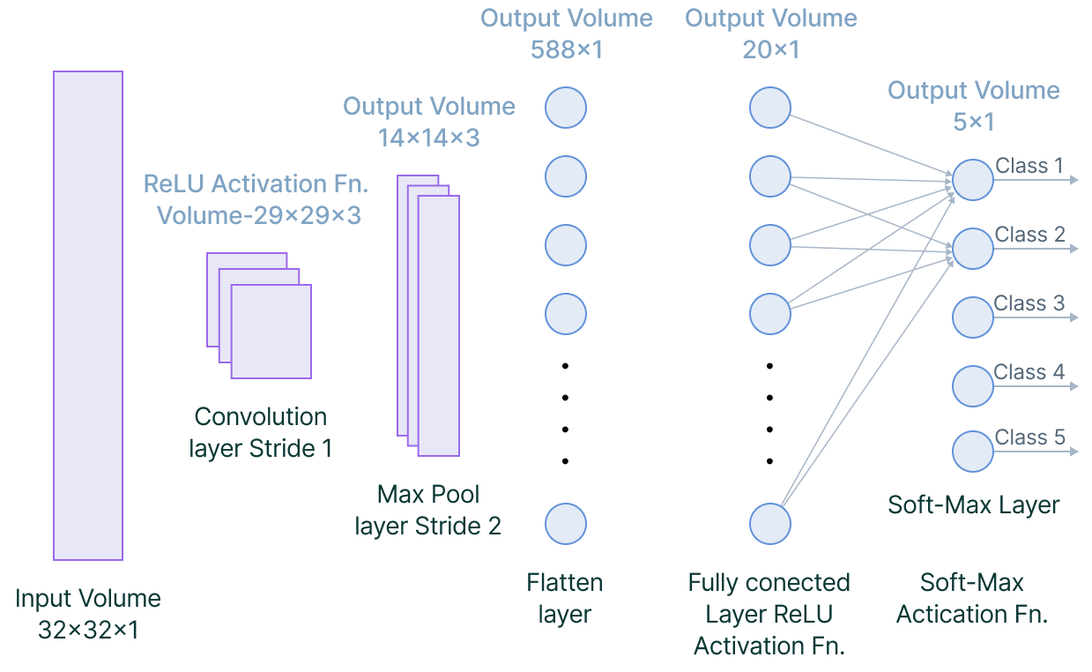

Fig 3.3: Basic Architecture of a CNN

A CNN-architecture constitutes 2-major components:
• A convolution function that is capable of separating/identifying the feature vector of a time-series data for analysis, which in a process is called Feature Extraction
• A FC layer that makes use of the o/p of the process to make predictions for the class of the provided data on basis of the features that were extracted in previous stages of the process.
Convolution-layers, max-pooling layers, and FC-layers comprise the CNN. These layers are stacked over and over to form a complex/dense CNN architecture. In addition to these layers, two additional estimators must be considered: the dropout-layer and the activation-function which are used later on for various purposes.

3.3 Modules Description

3.3.1 Data Preprocessing
Dataset containing time series data from three LIGO observatories are gathered.

HDF5 files are converted to numpy arrays and are sorted into their respective 3 Observatories.
Data is normalized and categorized.
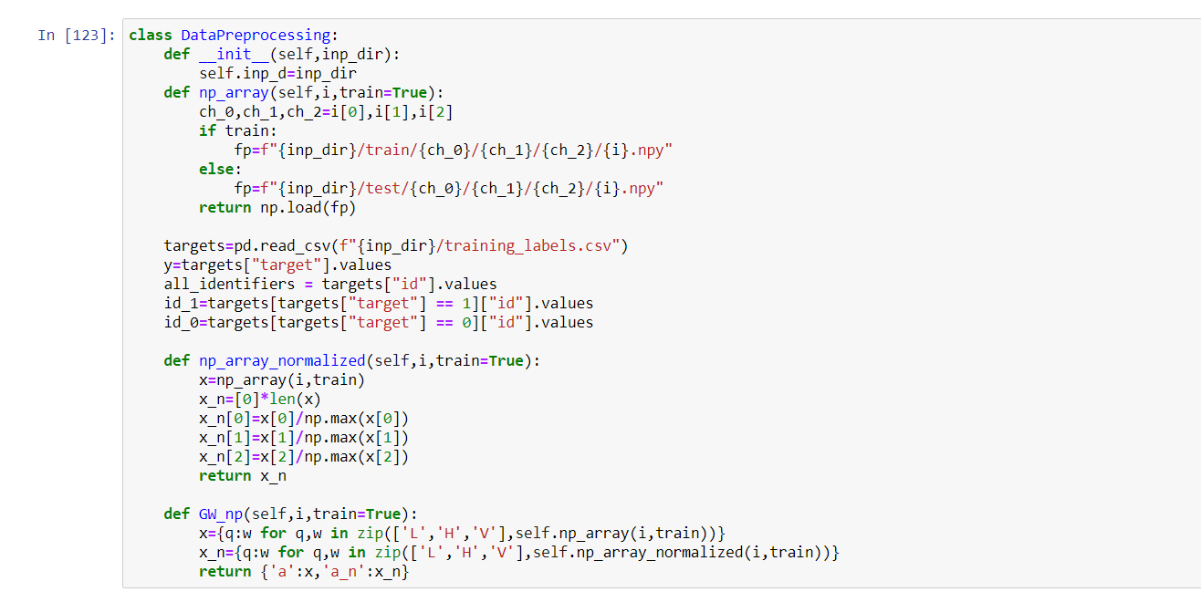

3.3.2 Signal Processing
Multiple signal processing methods (SQT, wiener filters, bandpass filtering etc)are described.
This is to remove gaussian and white noise from the signals to increase SNR
The data is aligned and rotated according to the orientations of the observatories.

3.3.3 Data Visualization
Here the time series data is plotted on a graph to better understand the signals.
The signals are plotted individually stacked horizontally and overlapped over each other
The signals are converted to frequency domain by performing Fourier transform on the waves to understand the frequency range of the signal.

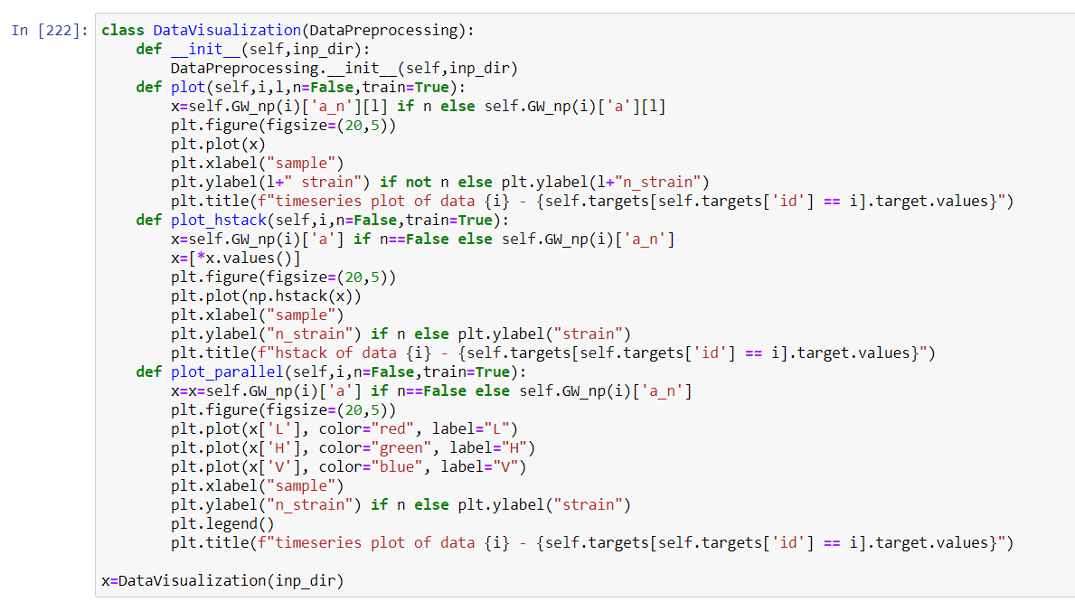

3.3.4 Prediction Module

Have designed a 2-D CNN with three convolution layers each followed by a max pooling layer and three dense layers two of them with RELU activation and the last one with a sigmoid activation so that the output layer consists of a value in the range of [0,1] indicating the probability of the signal containing a gravitational wave signal.

CHAPTER 4

Methodology

For this project we’ve used the data set from Kaggle. The data set used has time-series data obtained from three LIGO (Laser Interferometer Gravitational-Wave Observatory) namely LIGO Hanford, LIGO Livingston, VIRGO. These three observatories are sampled at 4096Hz for 2s. These data are either a combination of detector noise or detector noise + GW signal.

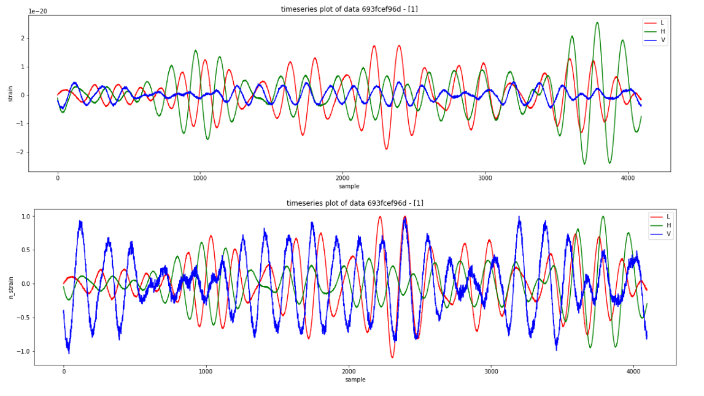
Fig.4.1: Data strains for normal vs normalized plotted for three observatories in time domain

The signal strength for most signals is very low for which we use multiple signal processing algorithms like whiten to remove gaussian noise, a low pass filter to filter out irrelevant higher frequencies. CQT filter is later applied on it and is passed as input to the 2-D CNN that we designed.

  - Discrete Fast Fourier Transform
Discrete-fast-Fourier-transform(DFFT) is a method that is used to convert discrete time-series data-signals to discrete frequency-domain signals. (DFFT) is used to calculate the frequency-spectrum of a signal.
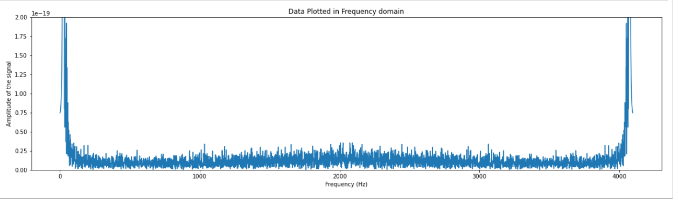
Fig.4.2: LIGO strain transformed to frequency domain
  - Power Spectral Density (PSD)
The Power Spectral Density (PSD) of a signal is the ratio of its power level to its frequency (Hz). PSDs are frequently used to characterise randomised broadband signals. The spectral resolution used to digitise the signal normalises the PSD's amplitude.
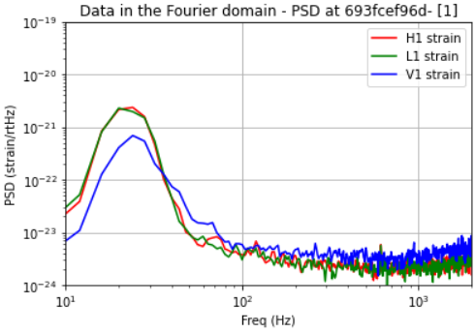
Fig.4.3: PSD for a sample signal

  - Amplitude Spectral Density (ASD)
The ASDs (Amplitude Spectral Density) are the square root of the PSD, which are the averages of the squares of the data's FFTs. They are an estimate of the detectors' "strain-equivalent noise" versus frequency, which limits the detectors' ability to identify GW signals.
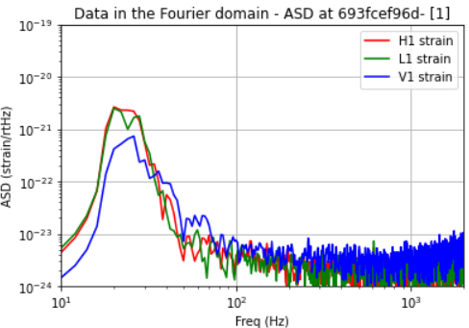
Fig.4.4: ASD for a sample signal
  - Low-Pass Filter
A low-pass filter is used to attenuate the signals that supersede the predetermined cutoff frequency. It is a concept taken from electronics and communication systems. It allows the lower frequencies to pass through while blocking the higher frequency signals. The response of this filter is determined during its initial design.
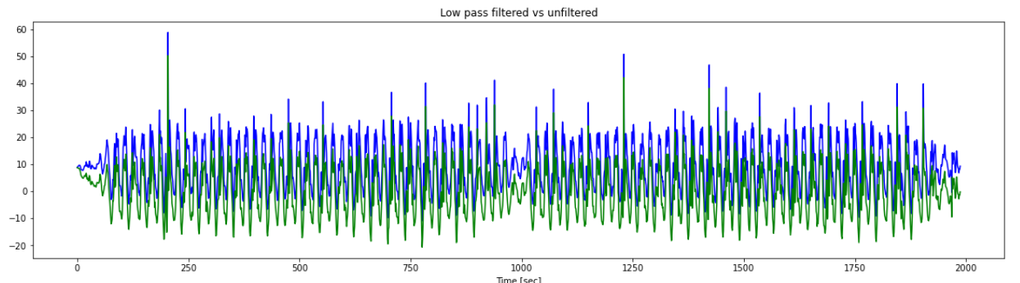

Fig 4.5: Lowpass filtered vs unfiltered plotted parallelly
  - Whitten
It is a linear transform that converts random variable vectors with a specified co-variance matrix to a set of new variables whose co-variance matrix is I. Thus implying each has a specific variance. This function is used to remove Gaussian or white noise from detector signal data.
  - CQT Filtered Signal
The constant-Q transform, also known as CQT, converts time-series data to the frequency domain.
The transform can be thought of as a series of logarithmically spaced filters-fk, with the k-th-filter having a spectral width of sigma-fk, which is equal to a multiple of the width of the previous-filter:
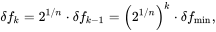

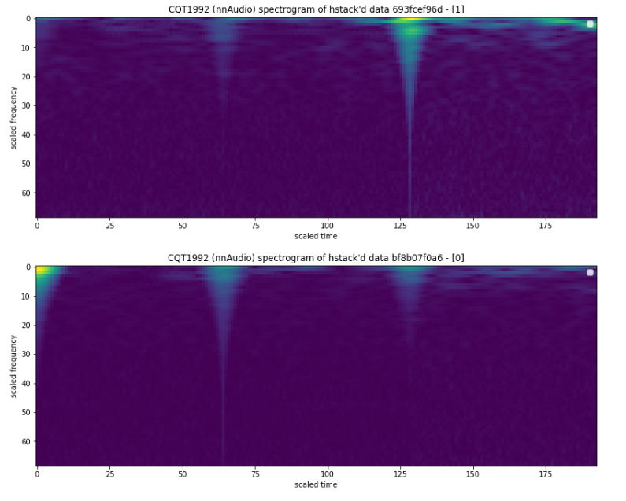
Fig.4.6: CQT Filtered Signal
  - DL Model Used
We’ve used a 2-D CNN for this. The 2-D CNN takes the preprocessed CQT passed LIGO data of shape (1,69,193,3). It outputs a regression value in the range [0,1].
The model has 3 Convolution layers of filter sizes (16,32,64). Max pooling is applied on every Conv layer to extract features from the data.
The outputs from Conv layers are flattened and passed as input to dense layers which reduce the output vector size. ReLu is used on the last but one dense layer. While Sigmoid activation is used to get a value in the range of [0,1].
To compare the performances of the model we have compared it against a 2-D CNN that also uses pre-trained weights from Efficient net. But this model outperformed it when it was compared for 1 epoch. This efficient net model had an accuracy of 52.85%.
It also was performing better when compared against 1-D CNN.
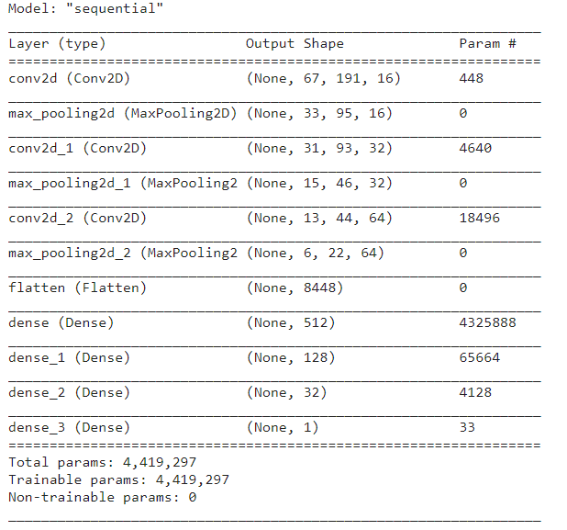

CHAPTER 5

Coding and Testing

  - Raw Code
5.1.1 Import the req libraries
Imported the libraries that we would be using for this project
import pandas as pd

import math
import numpy as np
import random

from tensorflow.keras.utils import Sequence
from tensorflow.keras import Sequential, utils, optimizers, metrics
import tensorflow as tf
import tensorflow.keras.layers as layers
from tensorflow.keras.models import load_model

import matplotlib
matplotlib.use('nbagg')

from matplotlib import pyplot as plt,mlab as mlb

from sklearn.model_selection import train_test_split

from random import shuffle
from nnAudio.Spectrogram import CQT1992v2
import torch

from efficientnet.tfkeras import EfficientNetB0, EfficientNetB1

from scipy import signal, fft
from scipy.interpolate import interp1d
from scipy.signal import butter, filtfilt, iirdesign, zpk2tf, freqz

from scipy.signal import welch

import os
import time
import seaborn as sns
from copy import copy,deepcopy
5.1.2 Data Preprocessing module
Has functions to transform the data as required.
class Data:
def __init__(self,in_dir):
self.inp_d=in_dir
def np_array(self,i,train=True):
c_0,c_1,c_2=[i[0],i[1],i[2]]
if train:
fp=f"{config.TRAIN_ROOT}{c_0}/{c_1}/{c_2}/{i}.npy"
else:
fp=f"{config.TEST_ROOT}{c_0}/{c_1}/{c_2}/{i}.npy"
return np.load(fp)
targets=pd.read_csv(f"{config.inp_dir}/training_labels.csv")
y=targets["target"].values
all_identifiers = targets["id"].values
id_1=targets[targets["target"] == 1]["id"].values
id_0=targets[targets["target"] == 0]["id"].values
sample_submission=pd.read_csv(f"{config.inp_dir}/sample_submission.csv")
def np_array_normalized(self,i,train=True):
x_=self.np_array(i,train)
x_n_=[0]*len(x)
x_n_[0]=x_[0]/np.max(x_[0])
x_n[1]=x_[1]/np.max(x_[1])
x_n[2]=x_[2]/np.max(x_[2])
return x_n_
def GW_np(self,i,train=True):
x_={q:w for q,w in zip(['L','H','V'],self.np_array(i,train))}
x_n_={q:w for q,w in zip(['L','H','V'],self.np_array_normalized(i,train))}
return {'a':x_,'a_n':x_n_}
def cqt_spectrogram(self,i,train=True):
cqt = CQT1992v2(sr=config.s_freq,hop_length=64, fmin=20, fmax=1024, bins_per_octave=12, norm=1, window='hann', center=True, pad_mode='reflect', trainable=False, output_format='Magnitude', verbose=False)
waveform=np.hstack(self.np_array(i,train))
waveform=waveform/np.max(waveform)
waveform=torch.from_numpy(waveform).float()
cqt_image=cqt(waveform)
cqt_image=np.array(cqt_image)
cqt_image=np.transpose(cqt_image, (1,2,0))
return cqt_image
def spectrogram(self,i,train=True):
waveform=np.hstack(self.np_array(i,train))
waveform=waveform/np.max(waveform)
(freq,time,intensity)=signal.spectrogram(waveform,config.s_freq, mode="magnitude", scaling="spectrum", window=('kaiser', 14))
return (freq,time,intensity)
5.1.3 Data Visualization Module
Has functions to plot the data in graphs and visualize it. It is used to analyze the data to identify relevant properties that could worked on
class DataVisualization(Data):
def __init__(self,in_dir):
Data.__init__(self,in_dir)
def plot(self,i,l,n=False,train=True):
x=self.GW_np(i)['a_n'][l] if n else self.GW_np(i)['a'][l]
plt.figure(figsize=(20,5))
plt.plot(x)
plt.xlabel("sample")
plt.ylabel(l+" strain") if not n else plt.ylabel(l+"n_strain")
plt.title(f"timeseries plot of data {i} - {self.targets[self.targets['id']==i].target.values}")
def plot_hstack(self,i,n=False,train=True):
x=self.GW_np(i)['a'] if n==False else self.GW_np(i)['a_n']
x=[*x.values()]
plt.figure(figsize=(20,5))
plt.plot(np.hstack(x))
plt.xlabel("sample")
plt.ylabel("n_strain") if n else plt.ylabel("strain")
plt.title(f"hstack of data {i} - {self.targets[self.targets['id']==i].target.values}")
def plot_parallel(self,i,n=False,train=True):
x=self.GW_np(i)['a'] if n==False else self.GW_np(i)['a_n']
plt.figure(figsize=(20,5))
plt.plot ( x['L'], color="red", label="L")
plt.plot ( x['H'], color="green", label="H")
plt.plot ( x['V'], color="blue", label="V")
plt.xlabel ("sample")
plt.ylabel ("n_strain") if n else plt.ylabel("strain")
plt.legend()
plt.title(f"timeseries plot of data {i} - {self.targets[self.targets['id']==i].target.values}")
def plot_cqt_spectrogram(self,i,train=True):
image=self.cqt_spectrogram(i,train)
plt.figure(figsize=(20,5))
plt.imshow(image)
plt.xlabel("scaled time")
plt.ylabel("scaled frequency")
plt.legend()
plt.title(f"CQT1992 (nnAudio) spectrogram of hstack'd data {i} - {self.targets[self.targets['id']==i].target.values}")
def plot_spectrogram(self,i,train=True):
(f,t,it)=self.spectrogram(i,train)
plt.figure(figsize=(20,5))
plt.pcolormesh(t,f,it,shading='gouraud')
plt.ylabel('Frequency [Hz]')
plt.xlabel('Time [sec]')
plt.ylim(0,100)
plt.title(f"Scipy spectrogram of hstack'd data {i} - {self.targets[self.targets['id']==i].target.values}")

x=DataVisualization(config.inp_dir)
5.1.4 Signal Processing
Has functions to reduce noise from the signal data and improve its SNR
5.1.4.1 PSD
def PSD(t_id):
fs=config.s_freq*2
fmin = 10
fmax = 2000
strain=x.GW_np(t_id)
f,Pxx_H1 = welch (strain['a']['H'], fs, nperseg=1024)
f,Pxx_L1 = welch (strain['a']['L'], fs, nperseg=1024)
f,Pxx_V1 = welch (strain['a']['V'], fs, nperseg=1024)
plt.figure()
plt.loglog (f,np.sqrt (Pxx_H1), 'r',label='H1 strain')
plt.loglog (f,np.sqrt (Pxx_L1), 'g',label='L1 strain')
plt.loglog (f,np.sqrt (Pxx_V1), 'b',label='V1 strain')
plt.axis ([fmin, fmax, 1e-24, 1e-19])
plt.grid ('on')
plt.ylabel ('PSD (strain/rtHz)')
plt.xlabel ('Freq (Hz)')
plt.legend (loc='upper right')
plt.title (f'Data in the Fourier domain - PSD at '+t_id+'- ['+str(x.targets[x.targets['id'] == t_id].target.values[0])+']')
PSD(s_id_1)
5.1.4.1 ASD
def ASD(t_id):
NFFT = 1*config.s_freq
fmin = 10
fmax = 2000
fs=config.s_freq*2
strain=x.GW_np(t_id)
Pxx_H1,f = mlb.psd ( strain ['a'] ['H'], Fs = fs, NFFT = NFFT)
Pxx_L1,f = mlb.psd ( strain ['a'] ['L'], Fs = fs, NFFT = NFFT)
Pxx_V1,f = mlb.psd ( strain ['a'] ['V'], Fs = fs, NFFT = NFFT)
psd_H1 = interp1d ( f, Pxx_H1)
psd_L1 = interp1d ( f, Pxx_L1)
psd_V1 = interp1d ( f, Pxx_V1)
plt.figure()
plt.loglog (f, np.sqrt(Pxx_H1),'r',label='H1 strain')
plt.loglog (f, np.sqrt(Pxx_L1),'g',label='L1 strain')
plt.loglog (f, np.sqrt(Pxx_V1),'b',label='V1 strain')
plt.axis ([fmin, fmax, 1e-24, 1e-19])
plt.grid ('on')
plt.ylabel ('ASD (strain/rtHz)')
plt.xlabel ('Freq (Hz)')
plt.legend (loc='upper right')
plt.title (f'Data in the Fourier domain - ASD at '+t_id+'- ['+str(x.targets[x.targets['id'] == t_id].target.values[0])+']')
ASD(s_id_1)
5.1.4.1 DFFT
#Applying DFFT on signal data
def dfft(s):
from numpy.fft import fft, ifft
sample_rate = 4096
# This returns the fourier transform coeficients as complex numbers
transformed_s = np.fft.fft(s[2])
# Take the absolute value of the complex numbers for magnitude spectrum
freqs_magnitude = np.abs(transformed_y)
# Create frequency that will span up to sample_rate
freq_axis = np.linspace(0, sample_rate, len(freqs_magnitude))
# Plot frequency domain
plt.figure(figsize=(20, 5))
plt.plot(freq_axis, freqs_magnitude)
plt.title('Data Plotted in Frequency domain')
plt.xlabel("Frequency (Hz)")
plt.ylabel("Amplitude of the signal")
plt.ylim(0,.2e-18)
plt.show()
5.1.4.1 Low Pass Filter
def b_low_pass(c, fs, o):
nyq=0.5*fs
n_c=c/nyq
return butter(o, n_c, btype='low', analog=False)

def b_low_pass_filter(d, c, fs, o):
return lfilter(*butter_lowpass(c, fs, o=o),d)
def lowpass(r_a_d):
fs=4096
nyq=0.5*fs
c=2.24e-25
n_c=c/nyq
o=1
#'f' for filtered signal and 'r' for removed signal
#numpy arrays are used for this
return {'f':b_low_pass_filter(r_a_d,c,fs,o),'r':r_a_d-b_low_pass_filter(r_a_d,c,fs,o)}
5.1.4.1 Whitten
def whiten(s, interp_psd, dt):
fq=np.fft.rfftfreq(len(s),dt)
FT=np.fft.rfft(s)
w_FT=FT/(np.sqrt(interp_psd(fq)/dt/2))
w_FT=np.fft.irfft(w_FT,n=len(s))
return w_FT
5.1.4.6 CQT transform
def cqt_1992(d):
d_c=np.hstack(d)
d_c=np.hstack(d)/np.max(d)
spectrogram_creator=CQT1992v2(
sr=2048, hop_length=64, fmin=20, fmax=1024, verbose=False
)
im=spectrogram_creator(torch.from_numpy(d_c).float())[0]
r=np.stack([im,im,im],axis = -1)
return r

f=cqt_1992
5.1.5 Data Generator
This module is to convert the dataset into the required form before passing the data as input to the DL model.
class DataGenerator_(tf.keras.utils.Sequence):
def __init__(self,path_,list_ID_,d,batch_size):
self.path_=path_
self.list_ID_=list_ID_
self.d=d
self.batch_size=batch_size
self.indexes=np.arange(len(self.list_ID_))

def __len__(self):
len_=int(len(self.list_ID_)/self.batch_size)
if len_*self.batch_size<len(self.list_ID_):
len_+=1
return len_

def __data_generation(self, list_IDs_temp):
X=np.zeros((self.batch_size,l,w,h))
y=np.zeros((self.batch_size, 1))
for i,ID in enumerate(list_IDs_temp):
id_=self.data.loc[ID, 'id']
file=id_+".npy"
path_in='/'.join([self.path, id_[0], id_[1], id_[2]]) + '/'
data_array=np.load(path_in+file)
X[i, ]=f(data_array)
y[i, ]=self.data.loc[ID, 'target']
return X,y
def __getitem__(self, id):
indexes = self.indexes[id * self.batch_size : (id+1) * self.batch_size]
list_ID_temp = [self.list_ID_[k] for k in indexes]
X, y = self.__data_generation(list_ID_temp)
return X, y
5.1.6 2-D CNN model
This is the 2-D CNN that was trained to classify a LIGO signal as detector noise or detector noise + GW signal
def get_model():
model = tf.keras.Sequential()

model.add(tf.keras.layers.Conv2D(filters=16,kernel_size=3,input_shape=(l,w,h),activation='relu',))
model.add(tf.keras.layers.MaxPooling2D(pool_size=2))

model.add(tf.keras.layers.Conv2D(filters=32,kernel_size=3,input_shape=(l,w,h),activation='relu',))
model.add( tf.keras.layers.MaxPooling2D( pool_size =2) )

model.add(tf.keras.layers.Conv2D(filters=64,kernel_size=3,input_shape=(l,w,h),activation='relu',))
model.add(tf.keras.layers.MaxPooling2D(pool_size=2))

model.add(tf.keras.layers.Flatten())

model.add(tf.keras.layers.Dense(512,activation="relu"))
model.add(tf.keras.layers.Dense(128,activation="relu"))
model.add(tf.keras.layers.Dense(32,activation="relu"))
model.add(tf.keras.layers.Dense(1,activation="sigmoid"))
model.compile(
optimizer = tf.keras.optimizers.Adam(learning_rate=config.l_r),
loss = 'binary_crossentropy',
metrics=['accuracy', tf.keras.metrics.TruePositives(), tf.keras.metrics.FalsePositives(), tf.keras.metrics.TrueNegatives(), tf.keras.metrics.FalseNegatives()]
)

return model

model=get_model()
model.summary()

Train=True
if Train:
history = model.fit(train_gen, validation_data=valid_gen, epochs = 1)
model.save('/kaggle/working/trained_cnn.h5')
model.save_weights('/kaggle/working/trained_cnn_weights.h5')
else:
model=load_model('../input/cnn-weights/trained_cnn1.h5')
model.load_weights('../input/lolnoob/trained_cnn_1.h5')
5.1.7 Prediction module
This function takes the path of the data signal file as input and outputs the predicted confidence score of the signal containing a GW signal.
def Predict(path):
t=np.load(path)
return model.predict(cqt_1992(t).reshape(1,69,193,3))
Target_1_test=['0000bb9f3e.npy','00026119ef.npy','0003920ef5.npy']
Target_0_test=['0003a9d0b0.npy','0003d34cd0.npy','000a3072ab.npy']
#qq=Target_1_test[1]
qq=Target_0_test[2]
Predict('../input/g2net-gravitational-wave-detection/train/0/0/0/{}'.format(qq))
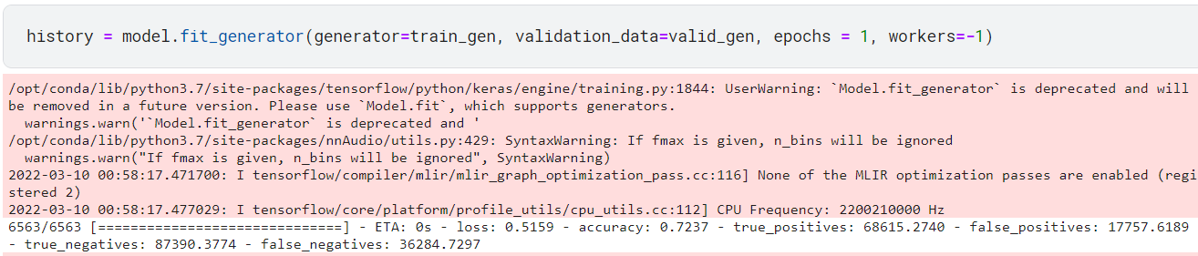

Fig 6.1: Accuracy of the model

CHAPTER 6

Results and Discussion

This project is aimed at reducing the time complexity of conventional methods like conventional matched-filtering and Bayesian inference approaches by providing a method to perform real time detection of the signals. This would in-turn be a lot
helpful to physicists who can analyze these waves to better understand the universe.

Normalized and filtered signal plotted for three LIGO observatories:
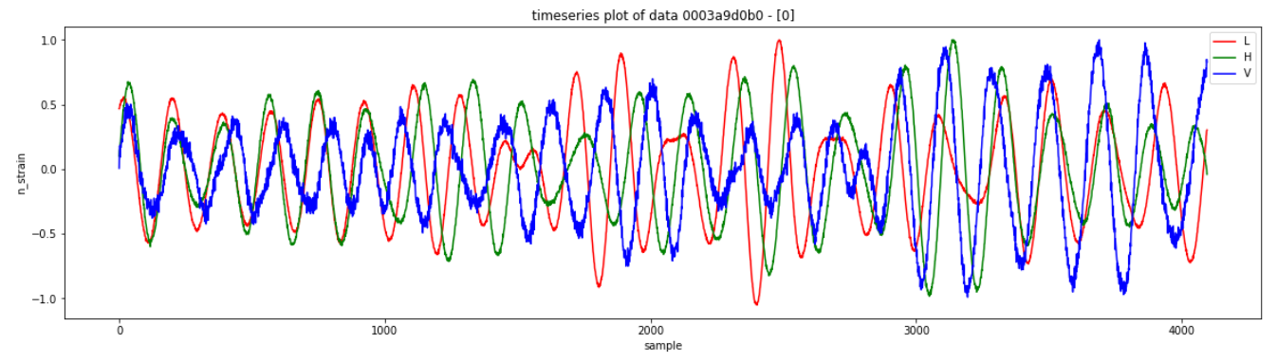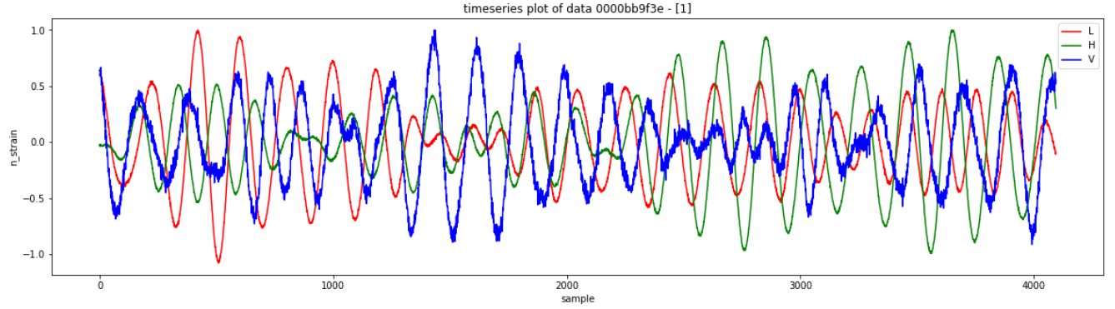
CQT filtered signals that is to be passed as input to the CNN model:
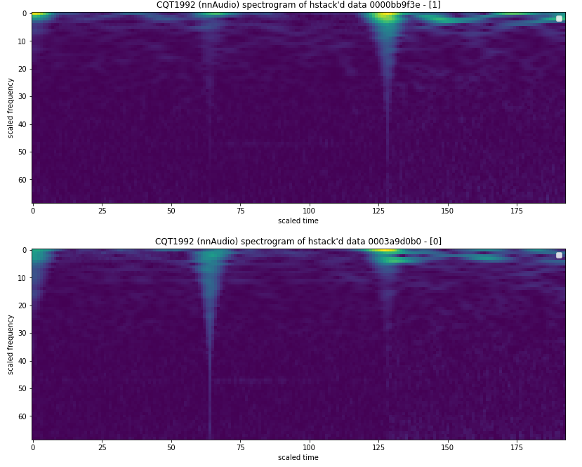

Output of this model is the confidence score of the gravitational wave’s existence in a signal:
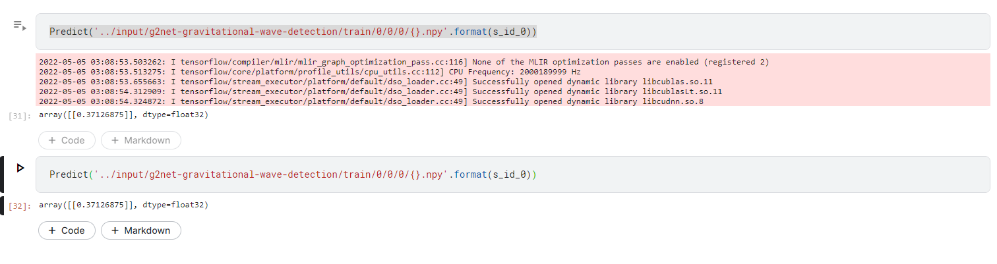

For this project we have implemented a Deep Learning model that is capable of predicting if a signal contains a GW or not. The had a validation accuracy of 84.209% and an accuracy of 72.37%.
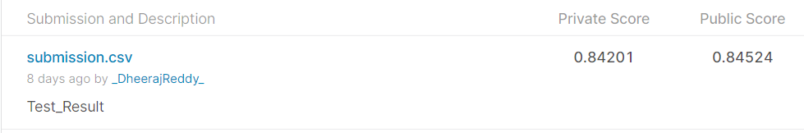

Fig 6.2: Score of the model determined from mean error of the predicted value

CHAPTER 7

Conclusion and Future Enhancement

  - Conclusion
The developed 2-D CNN model provides an alternative to conventional computationally expensive approaches. The model has a validation accuracy of 84.209% and an accuracy of 72.37% when tested for a data set consisted over 100000 files. Thus, we can conclude that DL approaches provide an efficient approach to detecting and recognizing gravitational wave parameters.

  - Future Enhancement
The model can be further be enhanced using complex neural network architectures that consume a lot of memory and time. The enhancement of the equipment could also help in improving the efficiency of the model. A large variety of data if fed to the neural network could also improve the accuracy of the model.
The development of signal processing techniques that could effectively remove noise from the signal data would further help in analyzing the signals that would effectively lead to developing a model that could perform better parameter estimation in predicting the underlying signal.

REFERENCES

[1] B. P. Abbott et al. (LIGO Scientific Collaboration and Virgo Collaboration)Phys. Rev. Lett. 116, 061102 – Published 11 February 2016
[2] Hunter Gabbard, Michael Williams, Fergus Hayes, and Chris Messenger Phys. Rev. Lett. 120, 141103 – Published 6 April 2018.
[3] Elena Cuoco et al 2021 Mach. Learn.: Sci. Technol. 2 011002.
[4] Plamen G.KrastevaKiranjyotGillbV. AshleyVillarbcEdoBergerb; 2012.13101; 2021.
[5] DanielGeorgeabE.A.Huerta;1711.03121;2018.
[6] Jure Zbontar, Li Jing, Ishan Misra, Yann LeCun, Stéphane Deny; "Barlow Twins: Self-Supervised Learning via Redundancy Reduction"-arXiv:2103.03230; 2021.
[7] https://ieeexplore.ieee.org/document/9174990%5C%22/authors; IEEE Access ( Volume: 8); 2020.
[8] S. R. Valluri, V. Dergachev, X. Zhang, and F. A. Chishtie Phys. Rev. D 104, 024065 – Published 26 July 2021
[9] Jingdong Chen, J. Benesty, Yiteng Huang and S. Doclo, "New insights into the noise reduction Wiener filter," in IEEE Transactions on Audio, Speech, and Language Processing, vol. 14, no. 4, pp. 1218-1234, July 2006, doi: 10.1109/TSA.2005.860851.
[10] A. Utina et al., "Deep learning searches for gravitational wave stochastic backgrounds," 2021 International Conference on Content-Based Multimedia Indexing (CBMI), 2021, pp. 1-6, doi: 10.1109/CBMI50038.2021.9461904.
[11] Schörkhuber, Christian & Klapuri, Anssi. (2010). Constant-Q transform toolbox for music processing. Proc. 7th Sound and Music Computing Conf.

Appendix

APPENDIX A

CONFERENCE SUBMISSION

Our paper “Gravitational Waves Detection using Deep Learning” was successfully submitted to IEEE IAS GUCON 2022. Our paper got the submission id “paper id : 96”

